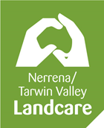
MINUTES OF THE 2020 ANNUAL GENERAL MEETING

Nerrena/Tarwin Valley Landcare Group
Annual General Meeting held on the Sunday 20th September 2019 at 10.00am via Zoom meeting.
Sue Miles opened the Zoom meeting at 10.05am and welcomed all attendees with an Acknowledgement of Country.

Attendees: Sue Miles, Coral & Kevin Hughes, Kate Walsh, Jill Vella, Kathy & Brad Westaway, Phil Poulton (proxy and by audio), Susan Neville, Herb Wildes, Justin Lamond, Jennifer Smit & Marijke Horvath, Michelle Tumino, Heather Smith, Luke Biram & Melissa Ellis and Chris Hughes (proxy)

Apologies: Eric Miles, Peter Walsh, Mike Vella, Corné Smit

- Minutes from the previous year’s Annual General Meeting were tabled having previously been circulated to the membership and available on the website.
Moved as a true and correct record by Kevin
Seconded Kathy
Carried

- Business arising from the previous minutes - none

- Annual reports –

Sue read her President’s report which is appended to these minutes and available on the website. After a short discussion where Mel reported that the sign on the rail trail was attracting much interest, the report was accepted by the meeting.
Moved to accept the Presidents report – Kate
Seconded Justin
Carried

Coral presented her Treasurer’s report and financial statement which is appended to these minutes and available on the website. Coral noted that the biggest income item was the Landcare grant.
Coral moved her report
Seconded Sue
Carried

Both the secretary, Jill and the Blackspur Creek Wetlands project officer, Kate tabled reports which are available on the website. Both were accepted by the meeting. Jill sought the approval of the membership to apply for the two grants listed in her report on the groups behalf which was granted. Kate noted that she continued to provide interested stakeholders with a bimonthly newsletter, and that liaising with the multiple stakeholders was sometimes challenging. She also noted that because the committee and members of the Landcare group were active and engaged it gives us credence with the stakeholders to influence positive environmental actions in the Blackspur Creek Wetlands project area.

- Election of Office bearers. Sue stepped down as President and gave control of the meeting to Herbert Wildes, South Gippsland Landcare Network Board Member. Herb declared all positions vacant and called for nomination for

President. Sue Miles was nominated by Jill seconded Michelle. Sue accepted the nomination and as there were no further nominations was elected unopposed.

Treasurer. Coral Hughes was nominated by Kate, seconded Sue. Coral accepted the nomination and as there were no further nominations was elected unopposed.

Secretary. Jill Vella was nominated by Phil, seconded Coral. Jill accepted the nomination and as there were no further nominations was elected unopposed.

Project Officer. Kate Walsh was nominated by Sue, seconded Jill. Kate accepted the nomination and as there were no further nominations was elected unopposed.

Sue resumed the chair of the meeting and thanked Herb.

- Motions on notice.
- Adopt the Action plan for 2020-2021 year.
‘That the Action Plan as tabled be adopted for the 2020/2021 Year’ moved Kathy, seconded Michelle, carried.
- Motion of Banking -
‘The Nerrena/Tarwin Valley Landcare group will continue to hold an account with the Bendigo Bank in Leongatha. It will have four registered signatories, President, Treasurer, Secretary and one other financial member, with two of the four registered signatories required to sign for any transaction’, moved Coral, seconded Justin, carried
- Setting of fees for next financial period.
‘That the fees for the three-year period be adopted pro rata for the remainder of the three-year period’, moved Herb, seconded Michelle, for 12, against 1, carried.
- Any other business
Kathy talked about the support given to members of the group by the West Gippsland Catchment Management Authority to support the revegetation works are members are doing with willow removal from local waterways.
Motion
‘that we write to the WGCMA to thank them for their good work and support of our projects’ Moved Kathy, seconded Jill, carried.

With the agenda being concluded Sue closed the meeting at 10.35. A short discussion on the next meeting was had before the zoom session closed.

NERRENA TARWIN VALLEY LANDCARE GROUP
2020 President's Report

2020 will be remembered for many reasons. Covid-19 – its restrictions and changes to our lives as we knew it – and - for our group a year of many projects mostly completed in isolation by the members.

MEMBERSHIP
We have currently 21 member families and have a three year membership fee. Our Blackspur Creek Wetlands project (BSCW) newsletter membership keeps in contact bimonthly with many organisations such as Major Roads, Shire, Water authorities, CMA, rail trail committee, the local branch of the Australian Plant Society and many private individuals.

ACTIVITIES
We had three meetings/ farm walks before March then a zoom meeting and many phone calls. We conducted our bird monitoring walks along the Great Southern rail trail and only missed two due to Covid-19 and several others due to weather conditions. In September Kate Walsh and I were invited to attend the South Gippsland Bird Observers Club meeting and presented on our bird monitoring project. Members Luke and Mel hosted Birds Australia members for a 4 day tour of South Gippsland, and group members were invited to make a presentation on our Blackspur Creek Wetlands project. Our group has two weed spray units to lend to members and the larger one was used twice through the year.

PROJECTS
We have had three major projects running including the ‘Making the Tarwin Terrific Again’, a Victorian Landcare Grants project. Brad and Kathy, fenced off and enhanced remnant vegetation on the Ruby Creek; a tributary of the West branch of the Tarwin River, and Jennifer, Corne and Marijke fenced off and revegetated some badly eroded gullies on their property that drains into the East branch of the Tarwin River. We visited both properties to see their projects before they commenced work and did a baseline bird survey on both the properties.

Our Tarwin project was supposed to include community tree plantings and further farm walks. Covid-19 put a stop to those plans, so we decided to use some of our group funds to buy some plants to distribute to group members to plant on their own properties. Members photographed or filmed short videos on their phones of their ‘separate but together’ tree plantings and we put them all together in a video of all of our works to make a virtual farm walk. This is now on our website and has been viewed by members and friends all over the world.

Another part of this grant was to erect a sign at the Great Southern Rail Trail (GSTR) Koonwarra bridges to inform rail trail users of our bird monitoring project and encourage them to take part. Terramirra Press designed the sign, with assistance from the previous GSRT committee, South Gippsland Shire Council staff, Main Roads Authority and the road contractors CPB Contractors who kindly erected it on the northern end of the Blackspur Creek bridge.

The Blackspur Creek Wetlands Project is still a major group focus. For many of us the actual commencement of the realignment works of the South Gippsland Highway over the Black Spur Creek/ Tarwin River was long awaited. Bird monitoring is a large part of this project at the current time, and we negotiated with Australian Birdlife for shared sites around the 3 bridges between Koonwarra and Minns Road. Our data is stored by Australian Birdlife which can be accessed by anyone via their Birdata App. QR codes and site details can be found on the sign at the first bridge on the rail trail. We have monthly Bird monitoring walks on the third Wednesday of the month when we can – viruses and the weather allowing.

Tarwin River Koonwarra willow removal and revegetation project at members Luke and Mel’s property continues with plantings of indigenous species on the Tarwin River banks. This involved the West Gippsland Catchment Management Authority removing willows, elms, and riverside weeds from the riverbank, then fencing the site out. We recently were granted 500 plants from the SGLN ‘One tree at a time’ project towards this project.

COMMUNICATION
Most of our communication was via email newsletters, both the group one and the Blackspur Creek Wetlands Project newsletter, phone calls and a Zoom meeting. We have 61 on our electronic group mailout and 170 members on our BSCW electronic mailout.

Two signs about our bird monitoring have been made for this project. One is a light pull up sign for inside use and the second sign is now located on the rail trail. Both include the site locations, and birds that can be commonly seen in the area.

Our group also wrote to South Gippsland Shire Council about our concerns about clearing native vegetation from roadside and the revegetation of the same.

We have 81 followers on our Facebook page and a website which is regularly updated with current information for members, BSCW project updates, weed and vegetation information for anyone to use. https://www.nerrenatarwinvalleylc.org.au/ .

GOVERNANCE
Our 2017 -2022 Action plan is current, and we have policies/ documents for bird monitoring, tree planting, epidemic guidelines and child safety and anti-bullying which is listed on our website. Our meeting minutes and financial reports are also listed.

SGLN
Four members were involved in the Online Strategy Workshops in April/May, as well as two members are involved in the Enhancing Soil Biology – Best Practice Soil Management project. Group member Herb Wildes sits on the SGLN board.

THANKS
I would like to thank all the members who have allowed us to have such a wonderful year and to achieve so much. Thanks goes to all our partners, authorities, supporters and community groups who have helped us throughout the year. I won't list them all in case I forget one, but we do appreciate your support and hope to work with you again.

Thanks to Kate Walsh, our BSCW project co-ordinator, who has worked tirelessly on making sure this project is relevant and engaging.

Thanks to Coral Hughes, our Treasurer, who has tackled online banking on our behalf and kept us financially on track.

To Jill Vella, our secretary, who has spent many hours keeping our group together. She is our IT guru, website manager, Facebook controller, project manager (that includes producing our wonderful video), and designer for our two bird monitoring signs. We are so lucky to utilise her skills.

Sue Miles
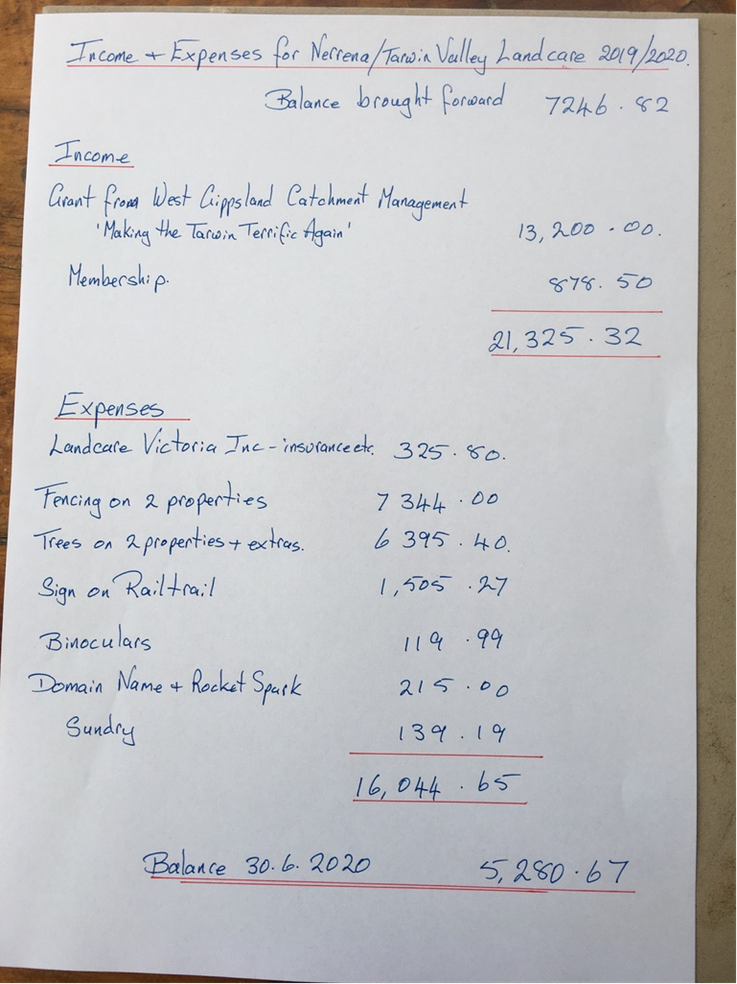
President Nerrena Tarwin Valley Landcare Group, July 2020.

