Nerrena Landcare Group- meeting held Friday 24st April at Kevin and Coral Hughes place Egans Rd Koonwarra

A walk and informal meeting was held and the Koonwarra Recreation Reserve @ 5.00pm along with Michelle Harris who is a local recreation consultant who has been engaged by the Committee of Management to develop the Koonwarra Recreation Reserve Master Plan.
The Master plan will identify a range of facility improvements and infrastructure projects to improve the reserve over the next 10 years. The Committee if looking to formalize the informal pathways to the Tarwin River west in the bushland area in between the oval and the river and would like some input from the Landcare group.
Present at this meeting were; Allan and Nena Caithness, Heather Smith, Veronica and Stuart Greaves, Louise Matthews, Kevin and Coral Hughes, Sue and Eric Miles, Zoe and Richard Baillie, Herb and Alex Wildes, and Dane Hawley from the Reserve committee.

WELCOME: President Kevin opened the meeting at 7.30 and welcomed Alex and Herb Wildes, Zoe and Richard Baillie, Sue and Eric Miles, Coral Hughes and Jill Vella

APOLOGIES Allan and Nena Caithness, Heather Smith, Veronica and Stuart Greaves, Louise Matthews, Peter and Kate Walsh, Jenene and Stuart Evans, Max and Jocelyn Boyd-Richards, Dianne Clark, Jill and Greg Edwards, Sue Neville, Andrea Tieman. M. Richard, S. Coral; Accepted.

MINUTES OF THE PREVIOUS MEETING M. Sue, S. Coral; Accepted

BUSINESS ARISING FROM PREVIOUS MEETING none

CORRESPONDENCE none

REPORTS –
Treasurer
Since the last meeting there are 13 families that are members. Bank balance is $1540.65.
We need to consider our subs amount at AGM
M. Coral, S. Zoe; Accepted with one dissension (Sue)

GENERAL BUSINESS
Koonwarra recreation reserve
Suggestions based on the walk and discussion earlier at the recreation reserve.
- A BBQ area would be great
- The present tracks are fine and no upgrade is needed (ie gravel) They add to the ambience and seem to be well maintained.
- Remove weeds (see attached doc)
- Plant to maintain character of riparian area. We noted there seems to be quite adequate recruitment of native river species, and perhaps all that was needed was a few more trees in areas where dieback has occurred or where tree weeds are removed.
- The reserve has a character with the old plantings of exotic trees that needs to be maintained.
- Drain in the south west corner from the oval could do with a culvert and cover so as to be easily walked over especially in the winter.
- Horses should be kept just inside the gate, not in the bush.

Ben and Jemima have a Koala grant and may need help with planting. Coral will see if they do.

NEXT MEETING Saturday the Ist August
Maybe
Jill and Howard Plowright as speakers or walk leaders.
Land of the Lyrebird movie.
AGM in September.

Meeting closed 8.20pm

There was some discussion about what should grow where – ie what was indigenous endemic flora.

http://www.depi.vic.gov.au/environment-and-wildlife/biodiversity/evc-benchmarks#gipp
This website contains files of information including benchmarks for all EVC’s in Victoria. It also has an interactive map.
http://mapshare2.dse.vic.gov.au/MapShare2EXT/imf.jsp?site=bim
This is what the map for my place looks like, showing that I have Damp heathy woodland, Lowland Forest and swamp scrub. I can then look up the bench marks for these EVC’s in the Gippsland Plains.
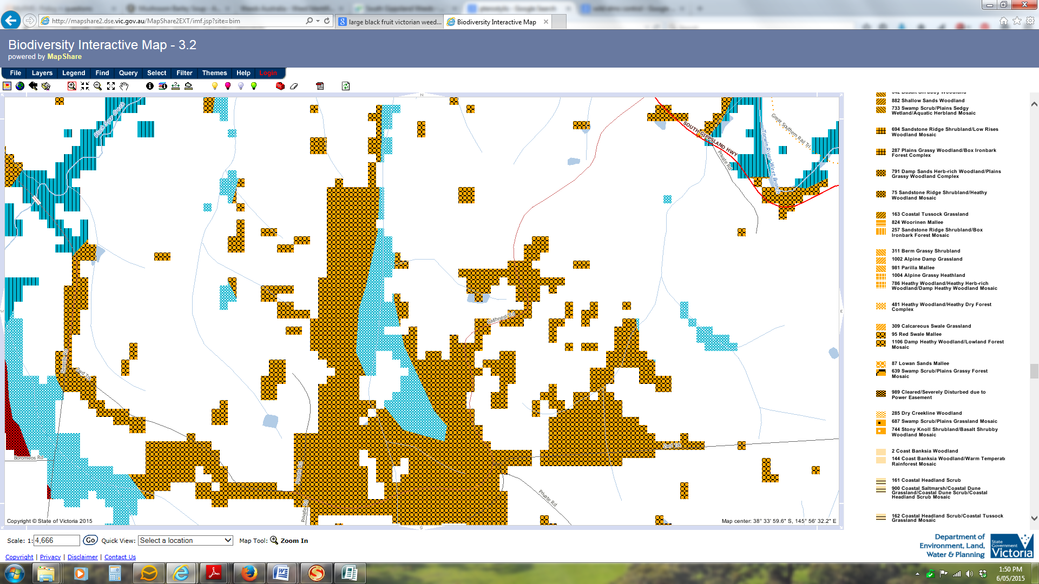

Jill Vella
Secretary.

